Kara Jones
CIS210
Assignment 1: Planning Your Week
May 2, 2020
Mark Stone

Introduction
In breaking down major tasks in my son’s homework/ virtual school transitioning from one task to the next alters the schedule slightly, yet focus to learn the material is the goal. In breaking down my son’s homework schedule I stick to 4 main time slots: review required assignments on Google classroom, work in Squiggle park (1st grade learning), watch and review posted videos and pick out a book to read for bedtime.
Discussion of 3 Major Tasks and Subtasks for Each
The Major tasks and the subtasks start with the reviewing of required assignments on Google classroom. The first subtask is to acclimate to a learning mind frame for my son and teaching frame of mind for myself. This includes getting the computer out, signing into the classrooms and letting my son navigate to areas to look over what needs to be covered. The second major task is working in Squiggle park (1st grade learning). This is where I help him focus on areas that he may need more work in and build his passion to learn by encouragement. The third major task is to watch, and review posted videos. I broke this into two subtasks taking in visual stimulus and then explaining in writing what he just learned. The last major task is to pick out a book to read for bedtime. The subtask of this is to get dressed for bed and we read a book.

Work Breakdown Structure (WBS) Screen Capture
Replace this text with a WBS screen capture that is created in MS Visio or an equivalent diagramming program. Delete this text from the template prior to submitting for grading. Perform research to address this topic substantially and follow the grading rubric.
Discussion of How the Gantt Chart Improves on the WBS
The Gnatt chart improves on the WBS because you have a visual of the time and the allotted to finish the task. This helps bring to actually the time needed between task or to transition to the next task. In addition, it shows you where time is lost and what needs to be altered to remain in the allotted time and where time is being lost.
Discussion of Task Dependencies and Predecessors / Successors
Task dependencies and Predecessors / successors help one put task in an order that can take away from lost time, put tasks in a logical order, and find the best system to finish task more proficiently. The Predecessor is the start of tasks and the end of all related successor tasks, Successors tasks are based on the start and end of the predecessors and the dependencies is the correlation between the predecessor and successor.

Gantt Chart Screen Capture
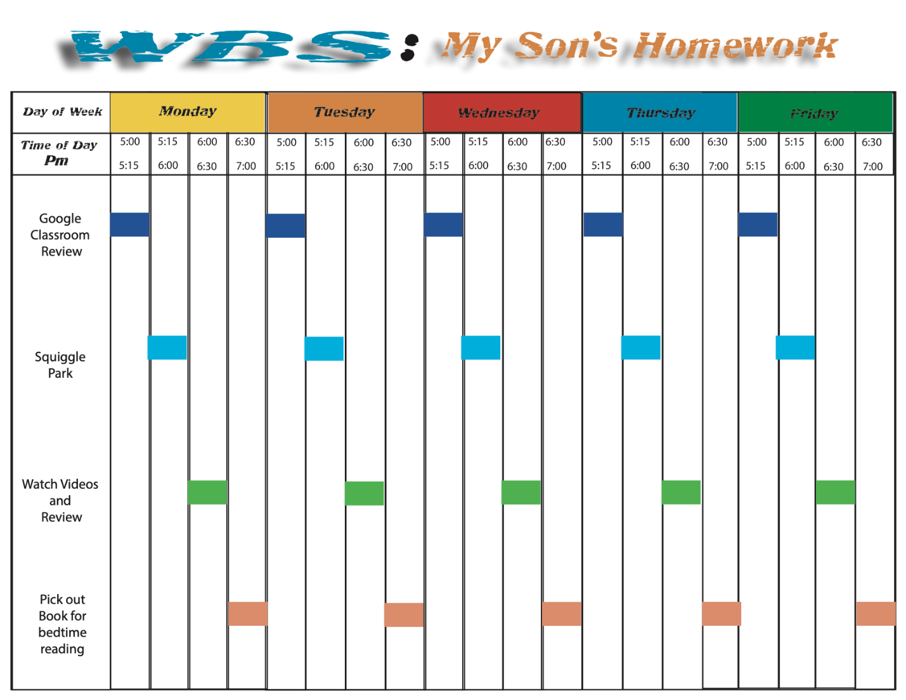

Conclusion
Using a Gnatt chart is a good way to have a visual representation of tasks that needs to be performed. The gnat chart gives one a way to grasp time and time remaining to complete a task in order to stay on schedule and be proficient in the allotted time frame.

References
Grant, M. (2020, February 18). Gantt Chart. Retrieved from https://www.investopedia.com/terms/g/gantt-chart.asp

Forsythe, D. (n.d.). Gantt Chart Dependencies. Retrieved from https://mavenlink.zendesk.com/hc/en-us/articles/360000456874-Gantt-Chart-Dependencies

